Issue 1: ccpa_age_class_key : As per the code the below Inventory ID’s should fall in Age Class As A, But in Target it is displaying as ‘B’ ( range is 0 to 30 Days only).

Select ID,a.Created,LKP.lower_range_value,LKP.upper_range_value,

b.ccpa_age_class_c_key ,LKP.row_key,Count(1)

FROM png_mdsdb.pg_ot_ccpa_pa_inventory_c_final a

LEFT JOIN

(Select x.source_id,max(x.lastupdated) as Lastupdated

FROM png_mdwdb.d_o_data_freshness x group by source_id) x ON a.sourceinstance=x.source_id

LEFT JOIN pgrita_mdwdb.d_png_ot_ccpa_numerita_c b ON a.ID=b.row_id AND a.sourceinstance=b.source_id

JOIN pgrita_mdwdb.d_lov LKP ON LKP.dimension_class='WH_OT_CCPA_AGE_CLASS_C~PROCESSING_ACTIVITIES'

AND timestampdiff(DAY,a.Created,convert_tz(x.lastupdated,'GMT','America/New_York'))

BETWEEN LKP.lower_range_value and LKP.upper_range_value

WHERE b.ccpa_age_class_c_key <>LKP.row_key

group by 1;

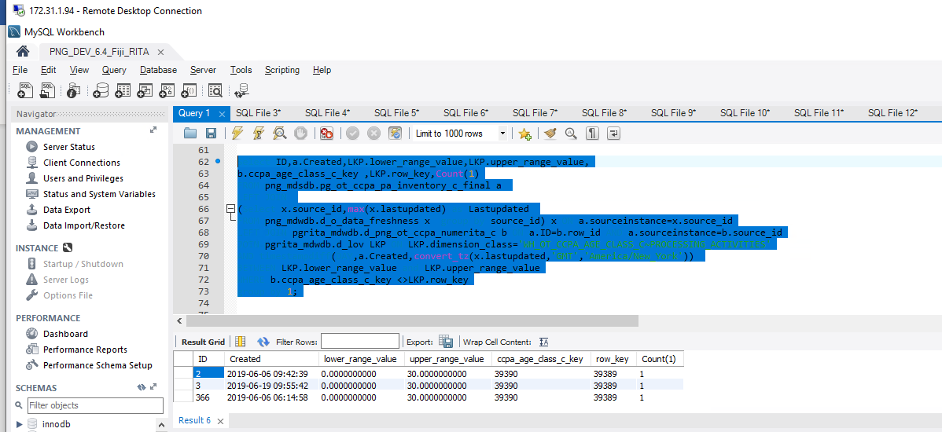

Issue 2 : Breach resp: evidence is Blanks , Should be UNSPECIFIED.

What is Breach Resp Scope Flag ? , not able to see from source file.

Data Breach is UNKNOW?

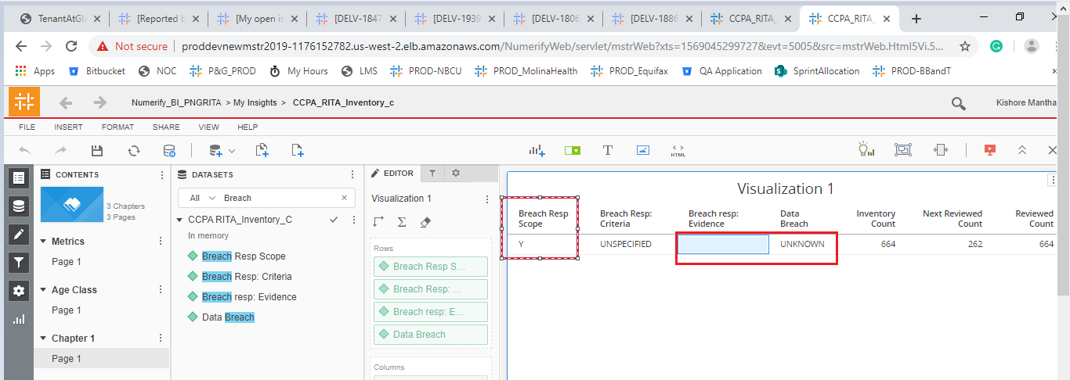

3. Compliance Priority is displaying as -1 and the Compliance Priority2 Flag is UNKNOWN .

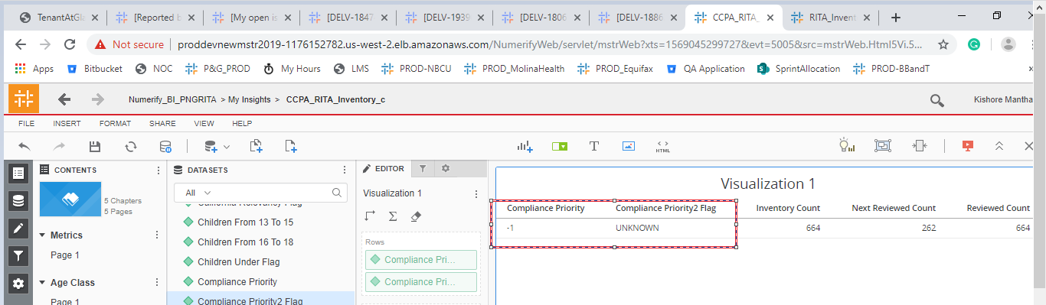

4. Flags are having UNKNOWN as values for one invalid record.

This is because the Inventory ID is populated as UNKNOWN.

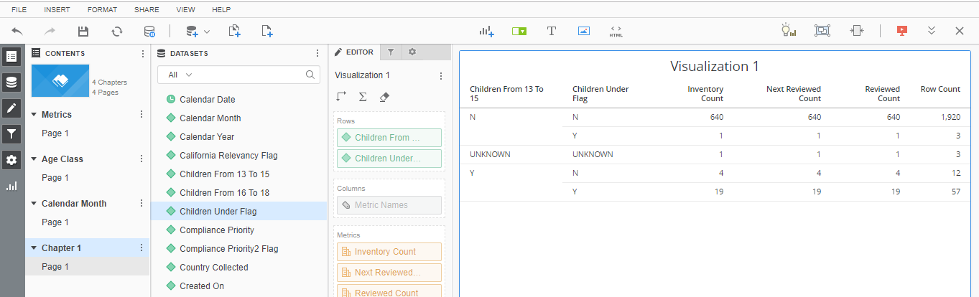

5. Countries Collected Attribute is displaying only UNKNOWN.

Select a.Country_collected,

Count(distinct a.ID)

FROM png_mdsdb.pg_ot_ccpa_pa_inventory_c_final a

group by 1;

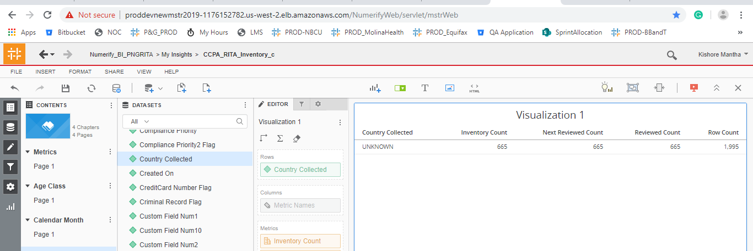

Issue 6: Data Stakeholders are having the UNKNOWN , should be UNSPECIFIED as it is having NULL at source level.

Select a.num_of_Data_Stakeholders_from_US,Count(1) as CNT

FROM png_mdsdb.pg_ot_ccpa_pa_inventory_c_final a

LEFT JOIN pgrita_mdwdb.d_png_ot_ccpa_numerita_c b ON a.ID=b.row_id AND a.sourceinstance=b.source_id

group by 1;

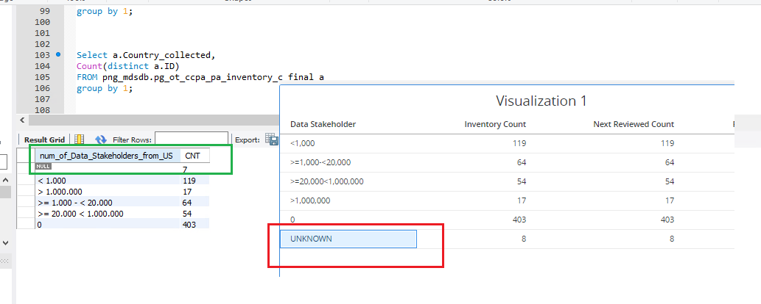

Issue 7: Image Soung Rec Flag ? ? ? what this column ? , Data is not matched with Source File .

Select a.Image_sound_recordings_156116006,a.Image_sound_recordings,

Count(distinct a.ID)

FROM png_mdsdb.pg_ot_ccpa_pa_inventory_c_final a

group by 1;

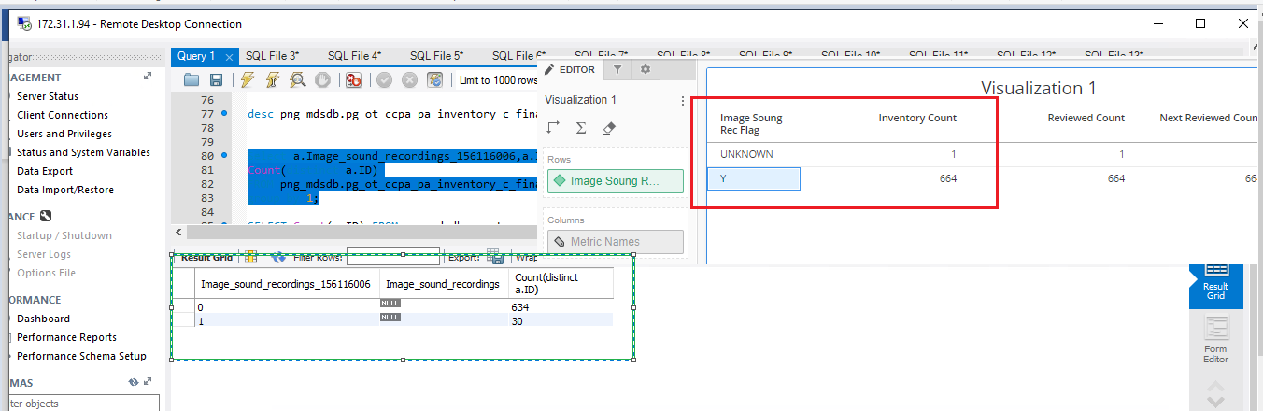

Issue 8: Where is the ‘Infosec Status’ attribute?

Select a.Reasonable_InfoSec_Status,

Count(distinct a.ID)

FROM png_mdsdb.pg_ot_ccpa_pa_inventory_c_final a

group by 1;

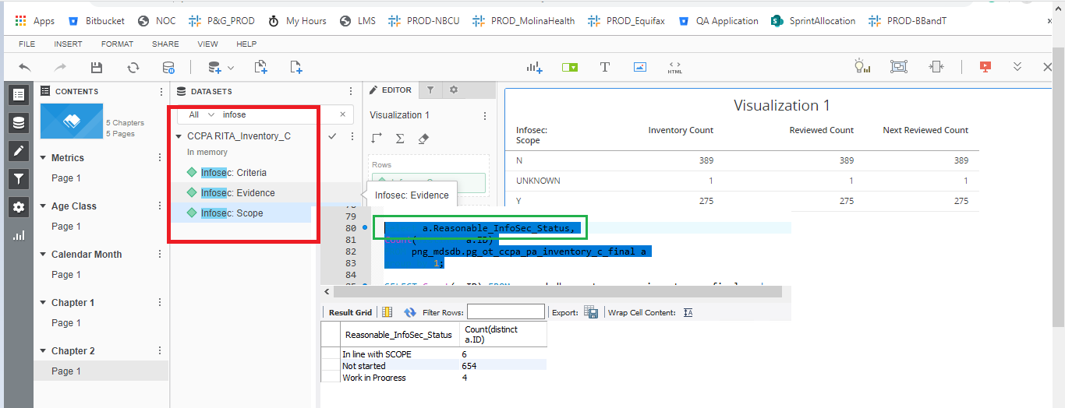

Issue 9: ‘Last_review_date’ is available for 9 records on File.

Select a.Last_review_date,

Count(distinct a.ID)

FROM png_mdsdb.pg_ot_ccpa_pa_inventory_c_final a

WHERE a.cdctype='X'

group by 1;

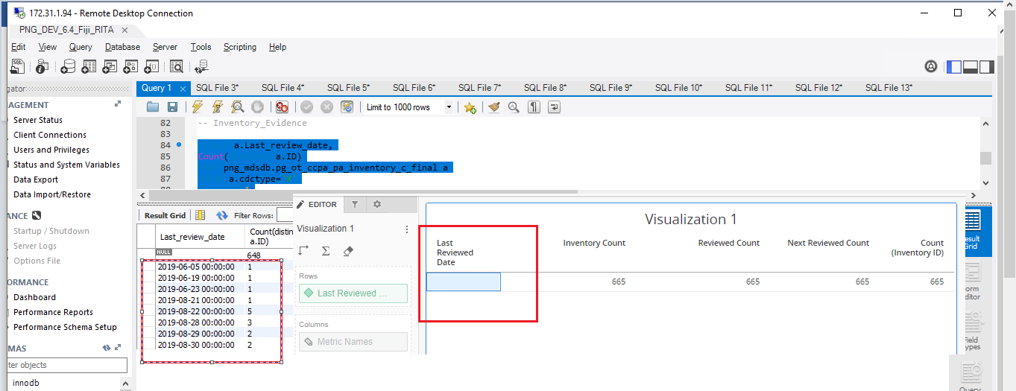

Issue 10:’ Minimization_Status’ is displayed as key format.

Select a.*Minimization_Status*,

Count(distinct a.ID)

FROM png_mdsdb.pg_ot_ccpa_pa_inventory_c_final a

WHERE a.cdctype='X'

group by 1;

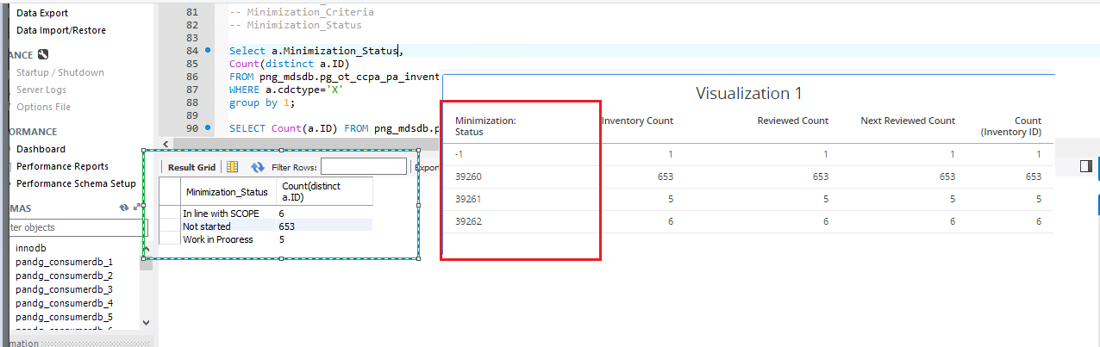

Issue 11 : PII Data Type attribute is displaying as key format.

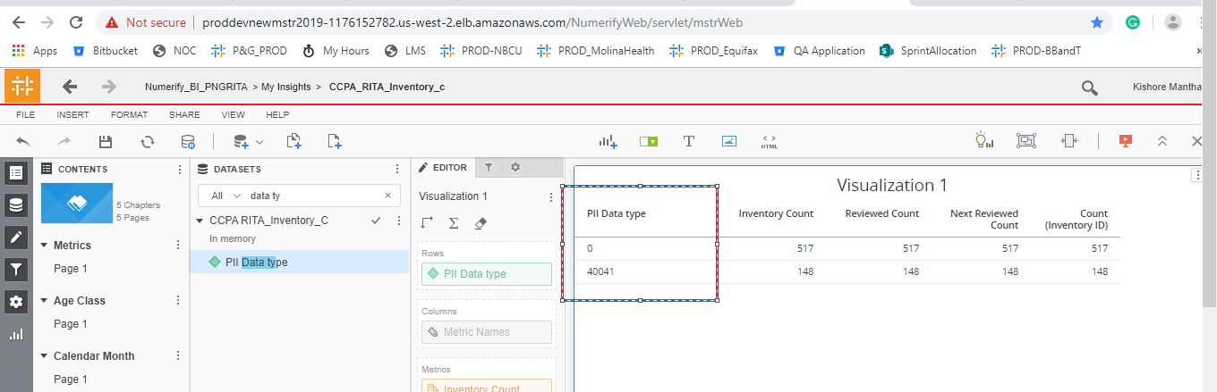

Issue 12 : Not able to view the relevant source name

What is the Source column for ‘PII Handled Flag’ ?

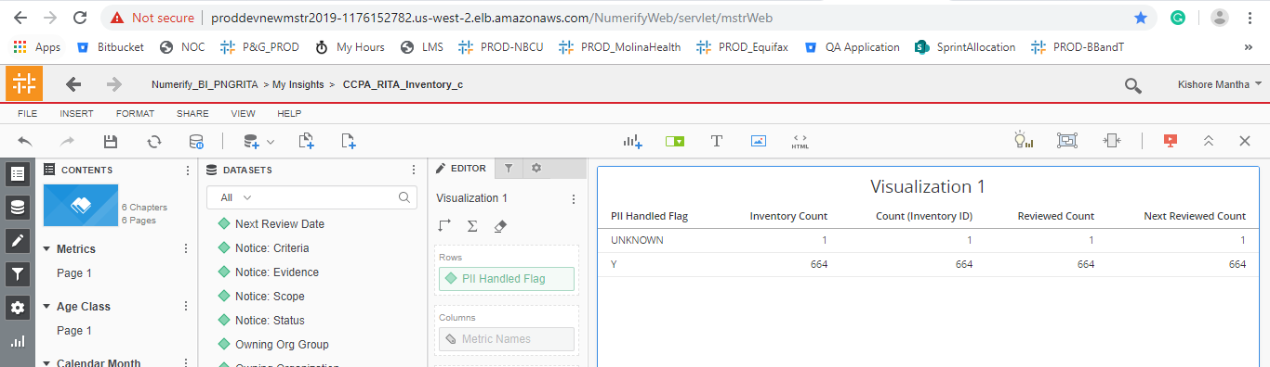

Issue 13: ‘Relegious Data Flag’

Should be named as 'Religious_or_philosophical_beliefs'.  
Misspelled.

Select a.Religious_or_philosophical_beliefs,

Count(distinct a.ID)

FROM png_mdsdb.pg_ot_ccpa_pa_inventory_c_final a

WHERE a.cdctype='X'

group by 1;

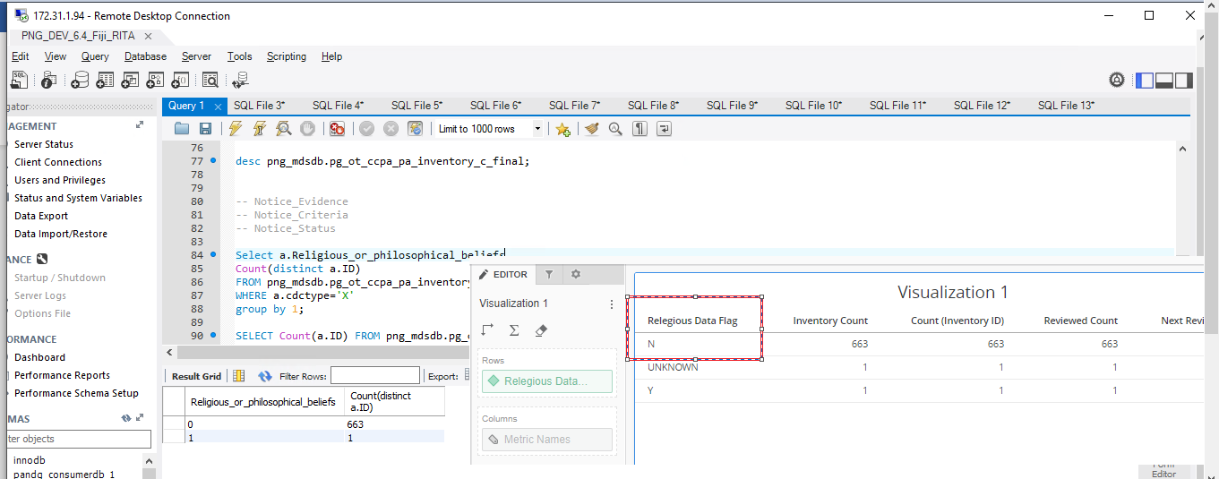

Issue 14:

‘Repository Sub-type’ is completely displaying as UNKNOWN, what is the Source column ?

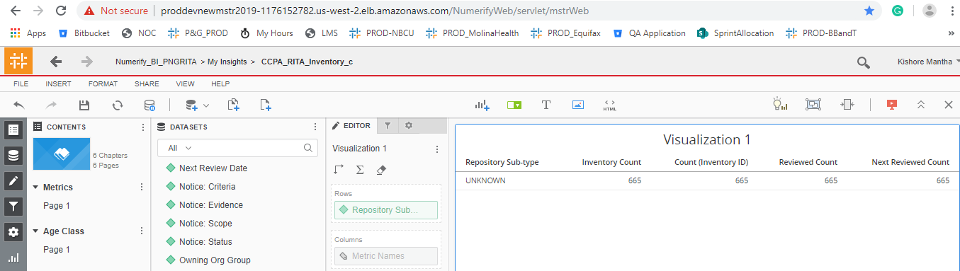

Issue 15: ‘SAP Vendor Name’ attribute is not available in Cube.

Select a.SAP_Vendor_Name,

Count(distinct a.ID)

FROM png_mdsdb.pg_ot_ccpa_pa_inventory_c_final a

WHERE a.cdctype='X'

group by 1;

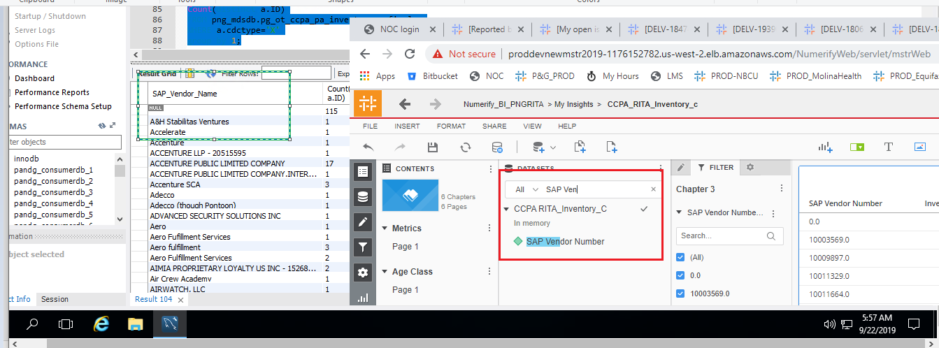

Issue 16: ‘SCOPE Number’ cannot be ‘UNKNOWN’ .It should be blank or NULL, as there are Nulls in source.

Select a.SCOPE_Number,

Count(distinct a.ID)

FROM png_mdsdb.pg_ot_ccpa_pa_inventory_c_final a

WHERE a.cdctype='X'

group by 1;

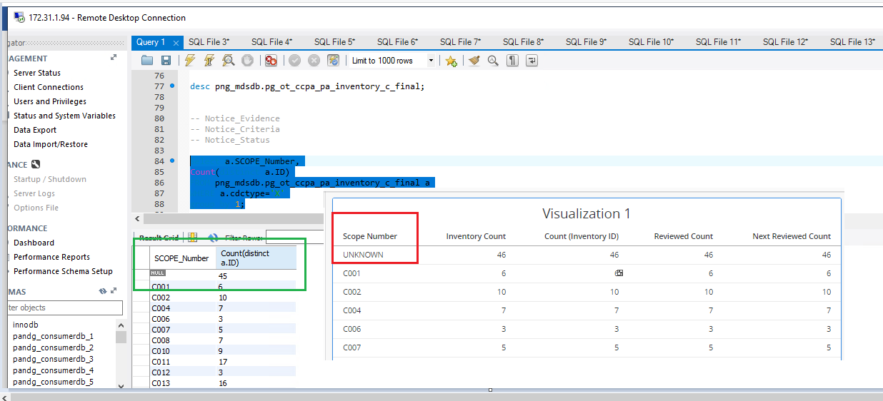

Issue 17 :’ Vendor Qualification’ should be not be UNKNOWN. Should be UNSPECIFIED.

Select a.Vendor_qualification,

Count(distinct a.ID)

FROM png_mdsdb.pg_ot_ccpa_pa_inventory_c_final a

WHERE a.cdctype='X'

group by 1;

